Week 9
Intro. To Literature & Composition
October 10-14

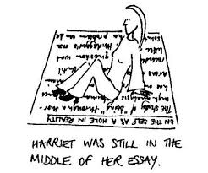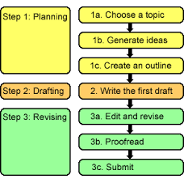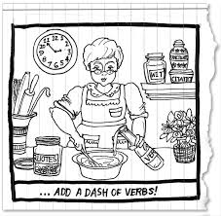
1.Cite strong and thorough textual evidence to support analysis of what the text says explicitly as well as inferences drawn from the text.
2. Determine a theme or central idea of a text and analyze in detail its development over the course of the text, including how it emerges and is shaped and refined by specific details; provide an objective summary of the text.
2.Write informative/explanatory texts to examine and convey complex ideas, concepts, and information clearly and accurately through the effective selection, organization, and analysis of content.

Because of my extended absence last week, final published compositions DUE Tuesday, October 18th with printed rubric and works-cited page**

OLSs:
Monday Weekly Letter---Meet in Lab 217 all week. Please sit in assigned seat
Model exemplar thesis statements and body paragraph to class
Distribute: annotated story and sample body paragraph example
Individually conference
HWK: revise body paragraphs and turn in on Google Classroom
Tuesday
Meet in Lab 217 all week. Please sit in assigned seat
Open Google Classroom
Access Expository Packet and Lead information on website or Google Classroom
In writing lab have students write introduction paragraphs for essay
Submit on Google Classroom assignment by tomorrow
Individual writing conference
HWK: compose and turn in on Google Classroom an introductory paragraph for essay using the format: Lead—BI---Thesis statement

Wednesday No School----Yom Kippur

Thursday Preview and Post samples of introduction methods
Work to compose a lead using an anecdote (4 point)
Review Quickly Conclusion paragraph guidelines on expository packet
Conferences on introductory paragraphs
Parent Teacher conferences tonight----Are your parents attending?
HWK: Revise introductory paragraph and write conclusion and submit on Google Classroom

Friday No School: NEOEA Day

Come to class Monday with draft of entire essay. Next, we will add MLA citations and complete essay.

